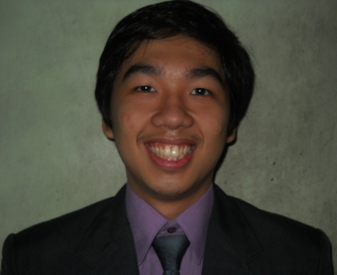**JOHANS BERMUDEZ CRUZ**

10-F Guevarra Street

San Francisco del Monte, Quezon City

Contact No.: +63 9279843018

Email address: [cruzjohans@gmail.com](mailto:cruzjohans@gmail.com)

**CAREER OBJECTIVE**

To find a job related to my educational background and be able to prove my knowledge and skills. To enhance my knowledge in the different areas of Human Resources

#### EDUCATIONAL BACKGROUND:

2008-2013 Trinity University of Asia, Cathedral Heights, QC

Bachelor of Science in Psychology

Bachelor of Science in Nursing (units earned)

2004-2008 Don Alejandro Roces Sr. Science and Technology HS

1998-2004 Trinity College of Quezon City

**ACADEMIC AWARD/ACCOMPLISHMENT:**

2012-2013 Scholar, AL Carson Scholarship Grant

Trinity University of Asia

#### INTERNSHIPS

September 2012 Trinity University of Asia Guidance Center

100 hours on Test Evaluation

May 2012 National Fisheries Research and Development Institute, QC

150 hours, Test Administration and Evaluation

April 2012 Nazal Halfway Home, Batasan Hills, QC

150 hours, Group Assessment

#### AFFILIATIONS

2013 up to present Volunteer

ILead Foundation, Brgy. Nayong Kanluran, QC

2012-2013 4th Year Representative, Psychology Society

Trinity University of Asia

2012-2013 Member, Honor Society

Trinity University of Asia

#### TRAININGS AND SEMINARS ATTENDED:

* Psychological Association of the Philippines Junior Affiliates

2012 January 14, Colegio de San Juan de Letran

“What’s the Big Idea? Metatheories and Metatheoretical Thinking in Psychology”

  Trinity University of Asia

February 25-26, 2011 Anne Raquel Resort

14th Skills Enhancement and Training on Human Relations

* Psychology Society, St. Joseph’s College

September 17, 2012 St. Joseph’s College

Graphology 101

#### SKILLS AND INTEREST

* Has good oral and written communication skills
* Has high computer literacy
* Knows American Sign Language (ASL)
* Knows basic Japanese

#### REFERENCES

Mr. Abner G. Lacson

Chief Executive Officer

Church Strengthening Ministry, Inc.

CSM Building, Pascor Drive, Sto. Nino, Parañaque City

+63 9213534247

Mrs. Helen Baguno

Professor

Trinity University of Asia

Cathedral Heights, E. Rodriguez Avenue, Quezon City

+63 9269801158

Mr. Ricky Instrella

Psychometrician

Trinity University of Asia

Cathedral Heights, E. Rodriguez Avenue, Quezon City

+63 9063874118